# Archer Support Requests

The Archer Support Requests app-pack is an offering provided through the Archer Exchange to enhance your existing Archer implementation. The Archer Exchange provides offerings to expand the use of Archer solutions into new business processes and address specific industry, geographic, regulatory, or technical requirements.

On this page

* Release notes
* About Archer Support Requests App-Pack
  + Key features and benefits
  + Prerequisites
  + Key terminology
* Archer Support Requests components
  + Architecture diagram
  + Swim lane diagram
  + Applications
  + Personas and access roles
  + Permissions chart
* Installing Archer Support Requests
  + Installation overview
    - Task 1: Prepare for the installation
    - Task 2: Install the package
    - Task 3 (optional): Enable actions by email in your instance
    - Task 4: Test the installation
  + Installing the package
    - Task 1: Back up your database
    - Task 2: Import the package
    - Task 3: Map objects in the package
    - Task 4: Install the package
    - Task 5: Review the package installation log
    - Step 6: Activate advanced workflow
    - (Optional) Enable actions by email for BPO review
* Using Archer Support Requests
  + Task 1: Create a support request
  + Task 2: Reviewing a support request
  + Task 3: Completing a support request
  + Task 4: Resubmitting a support request
* Certification environment

## Release notes

| Release Version | Published Date | Notes |
| --- | --- | --- |
| Archer 6.2 | November 2017 | Initial Release |
| Archer 6.9 | April 2021 | * Improved the user experience with   + Updated dashboards.   + Custom advance workflow warnings.   + Layout updates.   + Bulk update for user fields for the relevant persona.   + Actions By Email * New reduced number of Data Driven Events for better performance. * Added new field to identify solution area. |
| Archer 2024.06 | October 2024 | * BPO Reviewer field has been renamed as "Business Process Owner". * Old Classic Dashboards are merged into one dashboard and converted to next generation dashboard. * Automatic Record Permissions (Business Process Owner, Business User Record Permissions, Archer Admin/Developer Record Permissions) are merged into one and named as default Record Permission. Existing Automatic Record Permissions are removed from the package. * Two Subscription notifications are created for "Business Process Owner" and "Assigned To" to inform support requests assignment. |

## About Archer Support Requests App-Pack

Archer enables organizations to automate a variety of business processes to address their specific risk and compliance needs. As use of Archer grows within an organization, it is important to establish a process for managing requested changes to these automated business processes as well as the Archer environment itself. Tracking and prioritizing requested changes enables Archer administrators to respond quickly and efficiently to business requests, as well as minimize disruption to the system and existing business processes.

Archer Support Requests captures end-user requests and recommendations for enhancing Archer business processes and use cases. Organizations can more easily manage business team’s ideas for process improvements and innovations by enabling end users to submit suggestions for business process content, ideas for new reports, recommendations for improved workflow processes, proposals for updating dashboards and iViews, specifications for enhancing application layouts, requests for Archer access, and more. In addition, the offering assists Archer administrators to better manage and prioritize incoming requests by centralizing all requests.

### Key features and benefits

Establishing a consistent, centralized process for managing requests for additions or modifications to the Archer platform increases the consistency of responses, allows for a reduction in duplicated information, and reduces the workload on employees.

With Archer Support Requests, you will be able to:

* Automate the Support Request process from start to finish.
* Centralize all requests to expedite the process and remove the need for email communication.
* Enable the business user to review the status of any request and "Watch"/track any progress made to that request.
* Evaluate the request to determine impacts to existing business processes.
* Estimate the level of effort the request will require.
* Review approved task list of requests sorted by priority and due date.
* Monitor the development status of approved requests.
* Track historical trends by request type or business user making the submission.
* Request additional information from the business user making the request.
* Notify all parties involved when the status of a request has changed.

Benefits include:

* Simplify the process to suggest new innovations or report issues.
* Quickly request and obtain user access, modification, or removal.
* Quickly review the status of all Support Requests.
* Reduce the time required to review, evaluate and prioritize new requests.
* Reduce the time involved with establishing requests requirements.
* Escalate high priority requests for immediate action.
* Prioritize lower cost requests that deliver significant business impact.
* Eliminate duplicate requests while allowing Business Users to track the record.
* Plan needed upcoming development work.
* Quickly complete prioritized requests and release improvements.

### Prerequisites

| Components | Prerequisites |
| --- | --- |
| Archer Solution Area(s) | All |
| Archer Use Cases(s) | IT Asset Catalog or Business Asset Catalog |
| Archer Application(s) | Contacts |
| Uses Custom Objects | No |
| Requires Archer On-Demand Applications License | This offering requires Archer Support Requests requires one (1) Archer On-Demand Application licenses. |
| Archer Platform Requirements | Archer Platform Release 2024.06 and later |
| Supported Archer Environments | * On-Premises * SaaS |
| Partner/Vendor Requirements | N/A |
| Operating System | Windows |

### Key terminology

**Access Request**: control message originated by a business user for the purpose of adding, removing, or modifying a user or groups privileges in Archer.

**Application:** Database that stores a specific type of data record (for example, policies, assessments, assets, threats, vulnerabilities, controls).

**Archer Administrator/Developer:** Responsible for executing the request approved by the business process owner. For larger organizations / implementations, the Archer Administrator could be a system engineer that is responsible for configuring business processes, or someone that is responsible for the overall upkeep of the Platform. For medium or smaller organizations / implementations, this person could be the one and only admin for the Platform.

**Authorized User:**  A user who has logged into the system and has a right to perform some operation. The system knows the identity and permissions granted to this individual.

**Business Process Owner:** Owns the business process in which the change is being requested. They will evaluate the request to determine if it fits in line with the business process' roadmap plan and approve or decline the request, or ask for more information.

**Business User:** Suggests new innovations and processes improvements for the organization's risk and compliance processes to improve the design, content, and structure. The business user could be any user of the Archer system.

**Cross-Reference:** A field type that allows users to create associations between records in the same application (internal references) or records in two separate applications (external references). By adding a cross-reference to an application, the system will automatically add a Related Record field.

**Dashboard:** With reports defined and saved in the inventory of system reports, those identified as Global Reports may be added to dashboards. Each dashboard may include one of many reports in the format they were saved.

**Data Feed:** Continuous stream of structured data that provides users with current information from one to many sources. Data feeds are typically used by real-time applications in point-to-point settings. Types of Archer data feeds include Archer to Archer data feeds, Database Query data feed, File and FTP data feed, RSS data feed, and more.

**Notifications:** Emails that are sent from Archer to Users or Groups based on a schedule or a change in the record status.

**Record:** A collection of field values. Records are stored within applications, sub-forms or questionnaires.

**Report:** Saved search criteria that you can run again at a later time. In Archer, the construct for reports is a combination of a query and its related output presentation options. The data returned is filtered by a user permissions, allowing users to see only the data for which they have been granted access.

**Sub-Form:** For one application, administrators may develop multiple sub-forms to hold all related data. Sub-forms may be shared across applications, however changing a sub-form will affect all applications using that sub-form.

**Task:** Action items that have been assigned to a user in relation to the Support Request.

**User:** Any person who uses and is registered within the system. In this guide, the user is assumed to be an employee using Archer Support Requests.

**User Acceptance Testing (UAT):** The last phase of the software testing process. In this phase actual software users test the software to ensure it meets requirements and can handle required tasks. This phase is often referred to as beta testing.

**User Profile:** Preferences of the registered user that are saved within the system.

**Workspace:** Display mechanism that provides the user with a way to access their data.

## Archer Support Requests components

### Architecture diagram

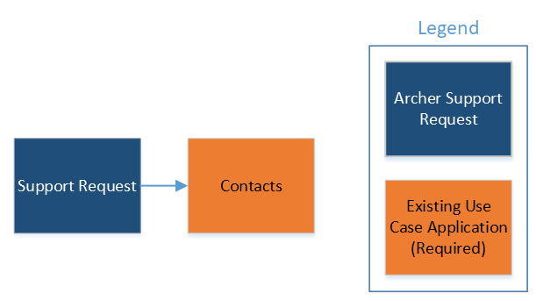

### Swim lane diagram

The Archer Support Request process begins when the Business User creates a new record. The Business User then selects which type of Support Request they would like to submit for approval. Once submitted, the Business Process Owner (BPO) receives a notification to review the request. The BPO has the option to approve the request, reject the request, or send the request back to the Business User for more information. If the request is approved it is assigned to an Archer Administrator/Developer for completion. The Archer Administrator can either cancel the request or build/develop the Support Request.

The following diagram shows the general workflow of the application.

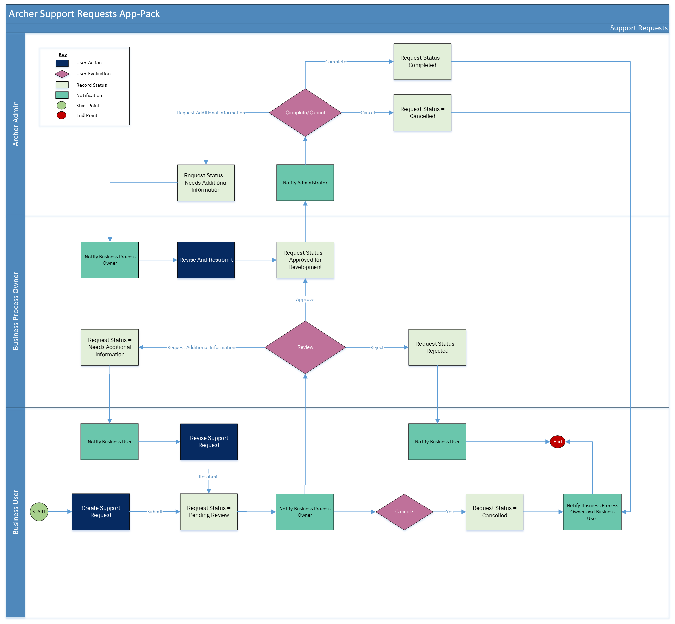

### Applications

| Application | Description |
| --- | --- |
| Support Requests | Captures end-user requests and recommendations for enhancing Archer business processes and use cases. Organizations can more easily manage business team’s ideas for process improvements and innovations by enabling end users to submit suggestions for business process content, ideas for new reports, recommendations for improved workflow processes, proposals for updating dashboards and iViews, specifications for enhancing application layouts, requests for Archer access, and more. In addition, the offering assists Archer administrators to better manage and prioritize incoming requests by centralizing all requests. |

### Personas and access roles

The following table describes the functions that make up the application’s organization roles. Depending on the organization of your company, these functions and responsibilities may vary.

| Function | Description |
| --- | --- |
| Archer Administrator/Developer | Responsible for executing the request approved by the business process owner. For larger organizations and implementations, the Archer Administrator could be a system engineer that is responsible for configuring business processes, or someone that is responsible for the overall upkeep of the Platform. For medium or smaller organizations and implementations, this person could be the one and only admin for the Platform. |
| Business Process Owner | Owns the business process in which the change is being requested. They will evaluate the request to determine if it fits in line with the business process' roadmap plan and approve or decline the request, or ask for more information. |
| Business User | Suggests new innovations and processes improvements for the organization's risk and compliance processes to improve the design, content, and structure. The business user could be any user of the Archer system. |

### Permissions chart

| Application | Archer Admin/Developer | Business Process Owner | Business User |
| --- | --- | --- | --- |
| Support Requests | RUD | RU | CRU* |

C = Create, R = Read, U = Update, D = Delete

*Indicates Record Permissions

## Installing Archer Support Requests

### Installation overview

Complete the following tasks to install the application.

#### Task 1: Prepare for the installation

1. Ensure that your Archer system meets the following requirements:
   * Archer Platform version 2024.06
2. Download the installation package
3. Obtain the Data Dictionary for the ODA by contacting your Archer Account Representative. The Data Dictionary contains the configuration information for the ODA.
4. Read and understand the "Packaging Data" section of Archer Help.

#### Task 2: Install the package

Installing a package requires that you import the package file, map the objects in the package to objects in the target instance, and then install the package. See Installing the Application Package for complete information.

#### Task 3 (optional): Enable actions by email in your instance

Actions by email can be enabled for your instance if required.

#### Task 4: Test the installation

Test the application according to your company standards and procedures, to ensure that the use case works with your existing processes.

### Installing the package

#### Task 1: Back up your database

There is no Undo function for a package installation. Packaging is a powerful feature that can make significant changes to an instance. Archer strongly recommends backing up the instance database before installing a package. This process enables a full restoration if necessary.

An alternate method for undoing a package installation is to create a package of the affected objects in the target instance before installing the new package. This package provides a snapshot of the instance before the new package is installed, which can be used to help undo the changes made by the package installation. New objects created by the package installation must be manually deleted.

#### Task 2: Import the package

1. Go to the Install Packages page.
   1. From the menu bar, click Admin menu.
   2. Under Application Builder, click Install Packages.
2. In the Available Packages section, click Import.
3. Click Add New, then locate and select the package file that you want to import.
4. Click OK.

The package file is displayed in the Available Packages section and is ready for installation.

#### Task 3: Map objects in the package

**Important:** This step is required only if you are upgrading to a later version of [ODA name].

1. In the Available Packages section, select the package you want to map.
2. In the Actions column, click  for that package.

The analyzer runs and examines the information in the package. The analyzer automatically matches the system IDs of the objects in the package with the objects in the target instances and identifies objects from the package that are successfully mapped to objects in the target instance, objects that are new or exist but are not mapped, and objects that do not exist (the object is in the target but not in the source).

**Note:** This process can take several minutes or more, especially if the package is large, and may time out after 60 minutes. This time-out setting temporarily overrides any IIS time-out settings set to less than 60 minutes.

When the analyzer is complete, the Advanced Package Mapping page lists the objects in the package file and corresponding objects in the target instance. The objects are divided into tabs, depending on whether they are found within Applications, Solutions, Access Roles, Groups, Sub- forms, or Questionnaires.

1. On each tab of the Advanced Mapping Page, review the icons that are displayed next to each object name to determine which objects require you to map them manually.

| Icon | Name | Description |
| --- | --- | --- |
| Awaiting mapping review | Awaiting Mapping Review | Indicates that the system could not automatically match the object or children of the object to a corresponding object in the target instance.  Objects marked with this symbol must be mapped manually through the mapping process.  **Important:** New objects should not be mapped. This icon should remain visible. The mapping process can proceed without mapping all the objects.  **Note:** You can execute the mapping process without mapping all the objects. The Awaiting mapping review icon is for informational purposes only. |
| Checkmark | Mapping  Completed | Indicates that the object and all child objects are mapped to an object in the target instance. Nothing more needs to be done with these objects in Advanced Package Mapping. |
| Missing objects | Do Not Map | Indicates that the object does not exist in the target instance or the object was not mapped through the Do Not Map option. These objects will not be mapped through Advanced Package Mapping, and must be remedied manually. |
|  | Undo | Indicates that a mapped object can be unmapped. This icon is displayed in the Actions column of a mapped object or object flagged as Do Not Map. |

1. For each object that requires remediation, do one of the following:
   * To map each item individually, on the Target column, select the object in the target instance to which you want to map the source object. If an object is new or if you do not want to map an object, select Do Not Map from the drop-down list.
   * **Important:** Ensure that you map all objects to their lowest level. When objects have child or related objects, a drill-down link is provided on the parent object. Child objects must be mapped before parent objects are mapped. For more details, see "Mapping Parent/Child Objects" in Archer Help.
   * To automatically map all objects in a tab that have different system IDs but the same object name as an object in the target instance, do the following:
   1. In the toolbar, click Auto Map.
   2. Select an option for mapping objects by name.

| Option | Description |
| --- | --- |
| Ignore case | Select this option to match objects with similar names regardless of the case of the characters in the object names. |
| Ignore spaces | Select this option to match objects with similar names regardless of whether spaces exist in the object names. |

* 1. Click OK.
  + The Confirmation dialog box opens with the total number of mappings performed. These mappings have not been committed to the database yet and can be modified in the Advanced Package Mapping page.
  1. Click OK.
  + To set all objects in the tab to Do Not Map, in the tool bar, click Do Not Map.

**Note:** To undo the mapping settings for any individual object, click  in the Actions column.

When all objects are mapped, the Checkmark icon is displayed in the tab title. The Missing objects icon is displayed next to the object to indicate that the object will not be mapped.

1. Verify that all other objects are mapped correctly.
2. (Optional) To save your mapping settings so that you can resume working later, see "Exporting and Importing Mapping Settings" in Archer Help.
3. Once you have reviewed and mapped all objects, click .
4. Select I understand the implications of performing this operation and click OK.

The Advanced Package Mapping process updates the system IDs of the objects in the target instance as defined on the Advanced Package Mapping page. When the mapping is complete, the Import and Install Packages page is displayed.

**Important:** Advanced Package Mapping modifies the system IDs in the target instance. Any Data Feeds and Web Service APIs that use these objects will need to be updated with the new system IDs.

#### Task 4: Install the package

All objects from the source instance are installed in the target instance unless the object can not be found or is flagged to not be installed in the target instance. A list of conditions that may cause objects not to be installed is provided in the Log Messages section. A log entry is displayed in the Package Installation Log section.

1. Go to the Install Packages page.
   1. From the menu bar, click Admin menu.
   2. Under Application Builder, click Install Packages.
2. In the Available Packages section, do the following:
   1. Locate the package file you want to install.
   2. In the Actions column, click Twin gears.
3. In the Selected Components section, select the components of the package that you want to install.
   * To select all components, select the top-level checkbox.
   * To install only specific global reports in an already installed application, select the checkbox associated with each report that you want to install.

**Note:** Items in the package that do not match an existing item in the target instance are selected by default.

1. Click Lookup.
2. For each component section, do the following:

**Note:** To move onto another component section, click Continue or select a component section in the Jump To drop-down menu.

1. In the Install Method drop-down menu, select an install method for each selected component.

* **Note:** If you have any existing components that you do not want to modify, select Create New Only. You may have to modify those components after installing the package to use the changes made by the package.

1. In the Install Option drop-down menu, select an install option for each selected component.

* **Note:** If you have any custom fields or formatting in a component that you do not want to lose, select Do Not Override Layout. You may have to modify the layout after installing the package to use the changes made by the package.

1. Click OK.
2. To deactivate target fields and data-driven events that are not in the package, in the Post-Install Actions section, select the Deactivate target fields and data-driven events that are not in the package checkbox. To rename the deactivated target fields and data-driven events with a user-defined prefix, select the Apply a prefix to all deactivated objects checkbox, and enter a prefix. This can help you identify any fields or data-driven events that you may want to review for clean up post-install.
3. Click Install.
4. Click OK.

#### Task 5: Review the package installation log

1. Go to the Package Installation Log tab of the Install Packages page.
   1. From the menu bar, click Admin menu.
   2. Under Application Builder, click Install Packages.
   3. Click the Package Installation Log tab.
2. Click the package that you want to view.
3. In the Package Installation Log page, in the Object Details section, click View All Warnings.

#### Step 6: Activate advanced workflow

1. Go to the Applications page.
   1. From the menu bar, click Admin menu.
   2. Under Application Builder, click Applications.
2. In the Applications section, select the Support Requests Application.
3. On the Advanced Workflow Tab, click ‘Activate’ in the top right corner of the page.
4. Then click ‘Save Workflow’ in the top left corner of the page.

#### (Optional) Enable actions by email for BPO review

Actions by email enables users to perform advance workflow actions from the email they receive from Archer. Customers can enable Actions by email for Business Process Owner Review. Actions by email needs to be enabled at multiple places before utilizing it:

1. Archer Control Panel: Advance Workflow Actions By Email Configuration should be enabled and updated.
2. Notification: Enable in the on-demand notification template.  An on-demand notification template is readily available on package installation.
3. Support Requests Application: Enable Actions By Email in the general tab of the application
4. Support Request Advance Workflow: Enable in the BPO Review user action node and select action by email notification template.
5. User Accounts: Enable in Account Maintenance section of the user account page. Ensure email id is configured for the user.

## Using Archer Support Requests

### Task 1: Create a support request

Users: Business User

1. Go to the Support Requests record.
   1. From the menu bar, click Archer Support Requests.
   2. Under Solutions, click Archer Support Requests.
   3. Under Applications, click Support Requests.
   4. In the Support Requests, click New Record.
2. Enter all pertinent information related to the request in the General Information section.
3. Enter a descriptive Request Title and Description for the Support Request.
4. Select Desired Completion Date by clicking the calendar icon next to the field.
5. Choose a Request Classification by clicking the down arrow next to the field and making your selection.
6. Choose the Request Type by selecting the appropriate radio button.
   1. Once you select the Request Type you will notice a new section will open under General Information.
   2. Enter all information related to your request by populating the displayed fields.
7. (Optional) Select any Watchers you would like to add to the request by clicking Ellipsis and selecting their user name.
8. (Optional) Select a Solution Area for your request
9. (Optional) Add attachments to the record by clicking the | Add New | button in the Attachments section.
10. (Optional) Add additional comments to the record by clicking the | Add New | button in the Comments section.
11. (Optional) Select the BPO Reviewer, Priority, Estimated Level of Effort in the Support Information Section.
12. (Optional) Select any related support requests by clicking the | Lookup | button in the Related Support Requests section.
13. Click Save in the Record Toolbar.

### Task 2: Reviewing a support request

Users: Business Process Owner

1. Select the Support Request you want to review and click the Edit button in the top of the record browser.
2. Add any comments for the Business User or Archer Administrator in the Business Process Owner Comments field in the General Information section.
3. Complete the fields in the Support Information section.
   1. If the request has already been made, push the down arrow next to the Duplicate Request field and select ‘Yes’. Select the duplicate request in Related Support Request field.
   2. Select the Archer Administrator/Developer in “Assigned To” field to assign the request.
   3. Select Estimated Level of Effort and Priority.
   4. Enter the Rationale for Level of Effort and Impact to Existing Business process in the respective fields.
4. (Optional) Add attachments to the record by clicking the | Add New | button in the Attachments section.
5. (Optional) Add additional comments to the record by clicking the | Add New | button in the Comments section.
6. To approve the request, click the Approve in Actions dropdown.
   1. Before approving a Support Request the Business Process Owner should select values for the Assigned To, Estimated Level of Effort, and Priority fields if not already provided.
7. To request more information from the Business User, click the Request Additional Information in the Actions dropdown.
   1. Requesting Additional Information requires text in the Business Process Owner Comments field.
8. To reject the request, click the Reject in the Actions dropdown.
   1. Rejected Support Requests requires text in the Business Process Owner Comments field.
9. Click Save in the Record Toolbar.

### Task 3: Completing a support request

Users: Archer Administrator/Developer

1. Select the Support Request you want to review and click the Edit button in the top of the record browser.
2. Complete the fields in the Release and Deployment section.
   1. Enter any comments for the Business Process Owner or Business User in the Archer Administrator/Developer Comments.
   2. Select the Build Phase by clicking the appropriate radio button.
   3. Select the Scheduled QA Deployment Date, Scheduled Release Date, and Production UAT Review date by clicking the date icon next to the respective fields.
   4. Select the QA Review Date, Actual QA Deployment Date and Production Release Date by clicking the date icon next to the respective fields.
   5. Complete the QA Approval Captured and Production UAT Approval Captured by clicking the down arrow next to the fields and making the appropriate selection.
   6. Enter the new Product Version after development is complete.
3. (Optional) Add attachments to the record by clicking the | Add New | button in the Attachments section.
4. (Optional) Add additional comments to the record by clicking the | Add New | button in the Comments section.
5. To complete the request, click the Request Complete in the actions dropdown.
6. To request more information from the Business Process Owner, click the Request More Information in the actions dropdown. Requesting Additional Information requires text in the Archer Administrator/Developer Comments field.
7. To cancel the Support Request, click the Cancel in the actions dropdown. Cancelled Support Requests require text in the Archer Administrator/Developer Comments field.
8. Click Save in the Record Toolbar.

### Task 4: Resubmitting a support request

Users: Business User/Business Process Owner

1. Select the Support Request you want to revise and click the Edit in the top of the record browser.
2. Make the revisions requested by the Business Process Owner or Archer Administrator/Developer.
3. (Optional) Add attachments to the record by clicking the Add New in the Attachments section.
4. (Optional) Add additional comments to the record by clicking the Add New in the Comments section.
5. To resubmit click the Resubmit Request in the actions dropdown.
6. (For Business User) To cancel click the Cancel Request in the actions dropdown.

## Certification environment

Date tested: October 2024

| Product Name | Version Information | Operating System |
| --- | --- | --- |
| Archer Suite | 2024.06 | Virtual Appliance |